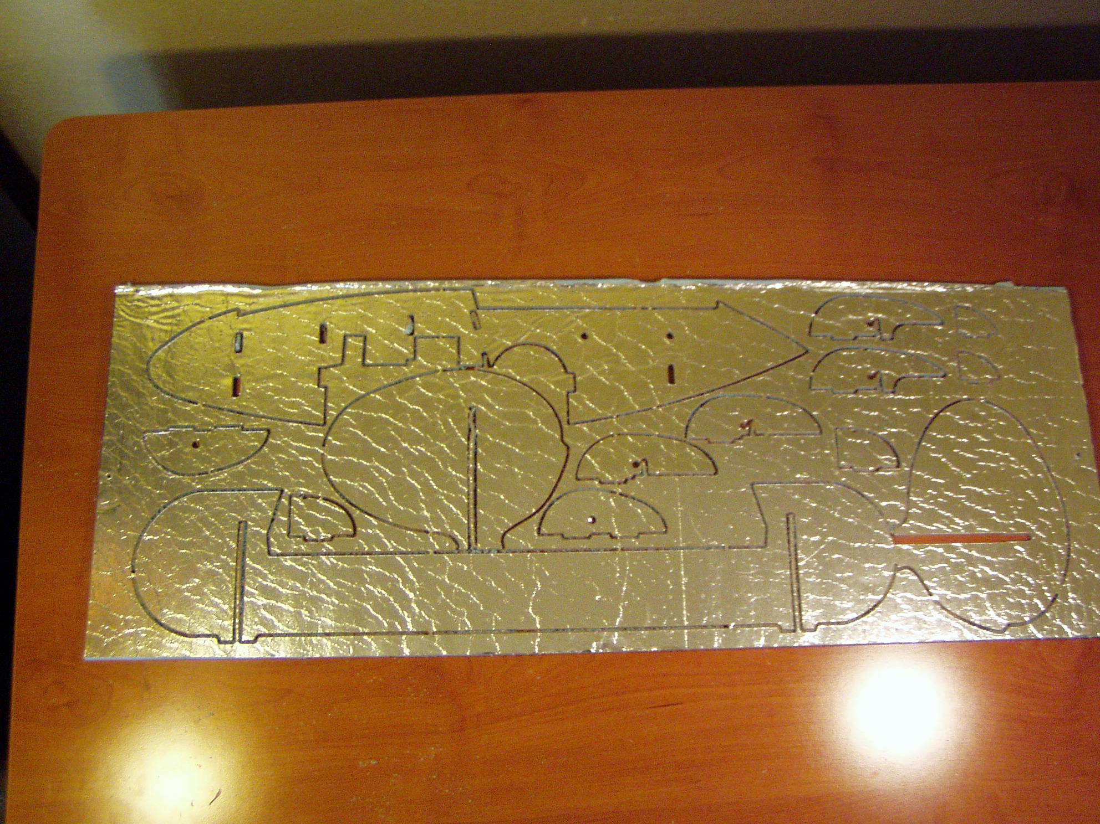
Grab the sheet for the main fusaluge parts and punch all the parts out and remove the protective paper backing.
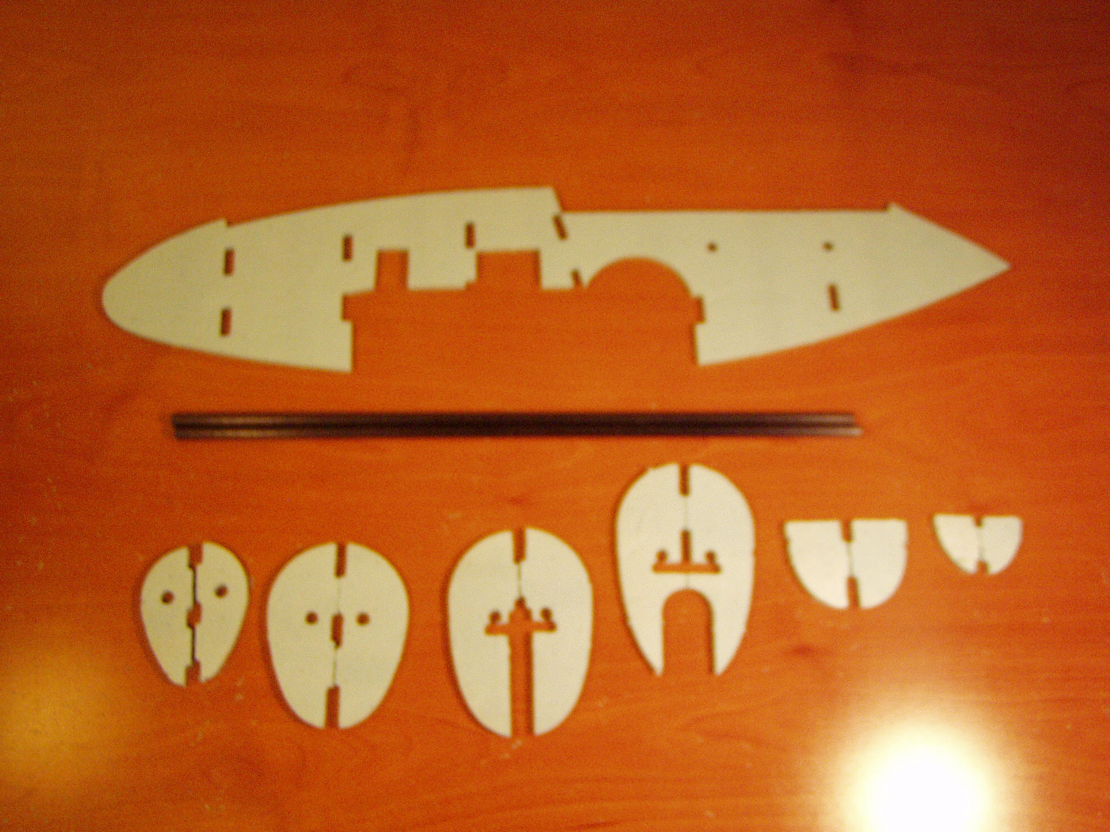
All of the foam parts for the main fuselauge are shown with the two carbon fiber shafts. There are two of each of the formers.
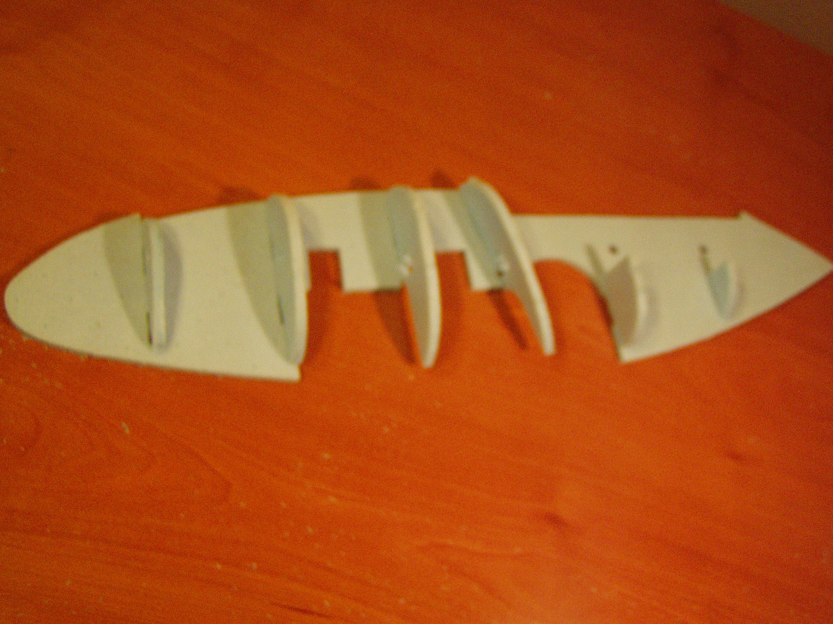
Pin the main fuse center to the work surface and position the formers in position as shown. Refer to the earlier photo to identify which former goes in which slot.
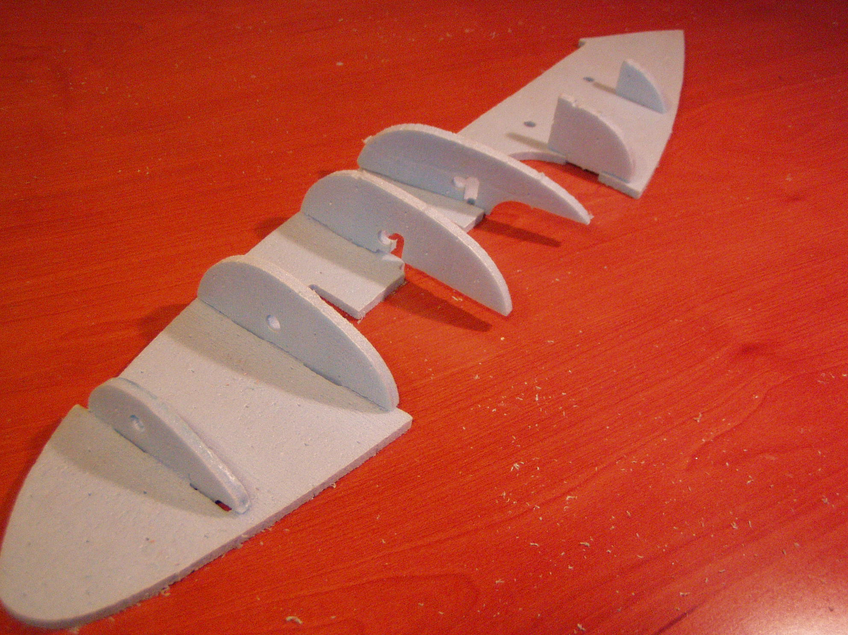
Once you are satisfied with the position and fit of the former halves, glue them in position. Once the glue has dried, remove the fuselage from the work surface and glue the opposite former sides into place.
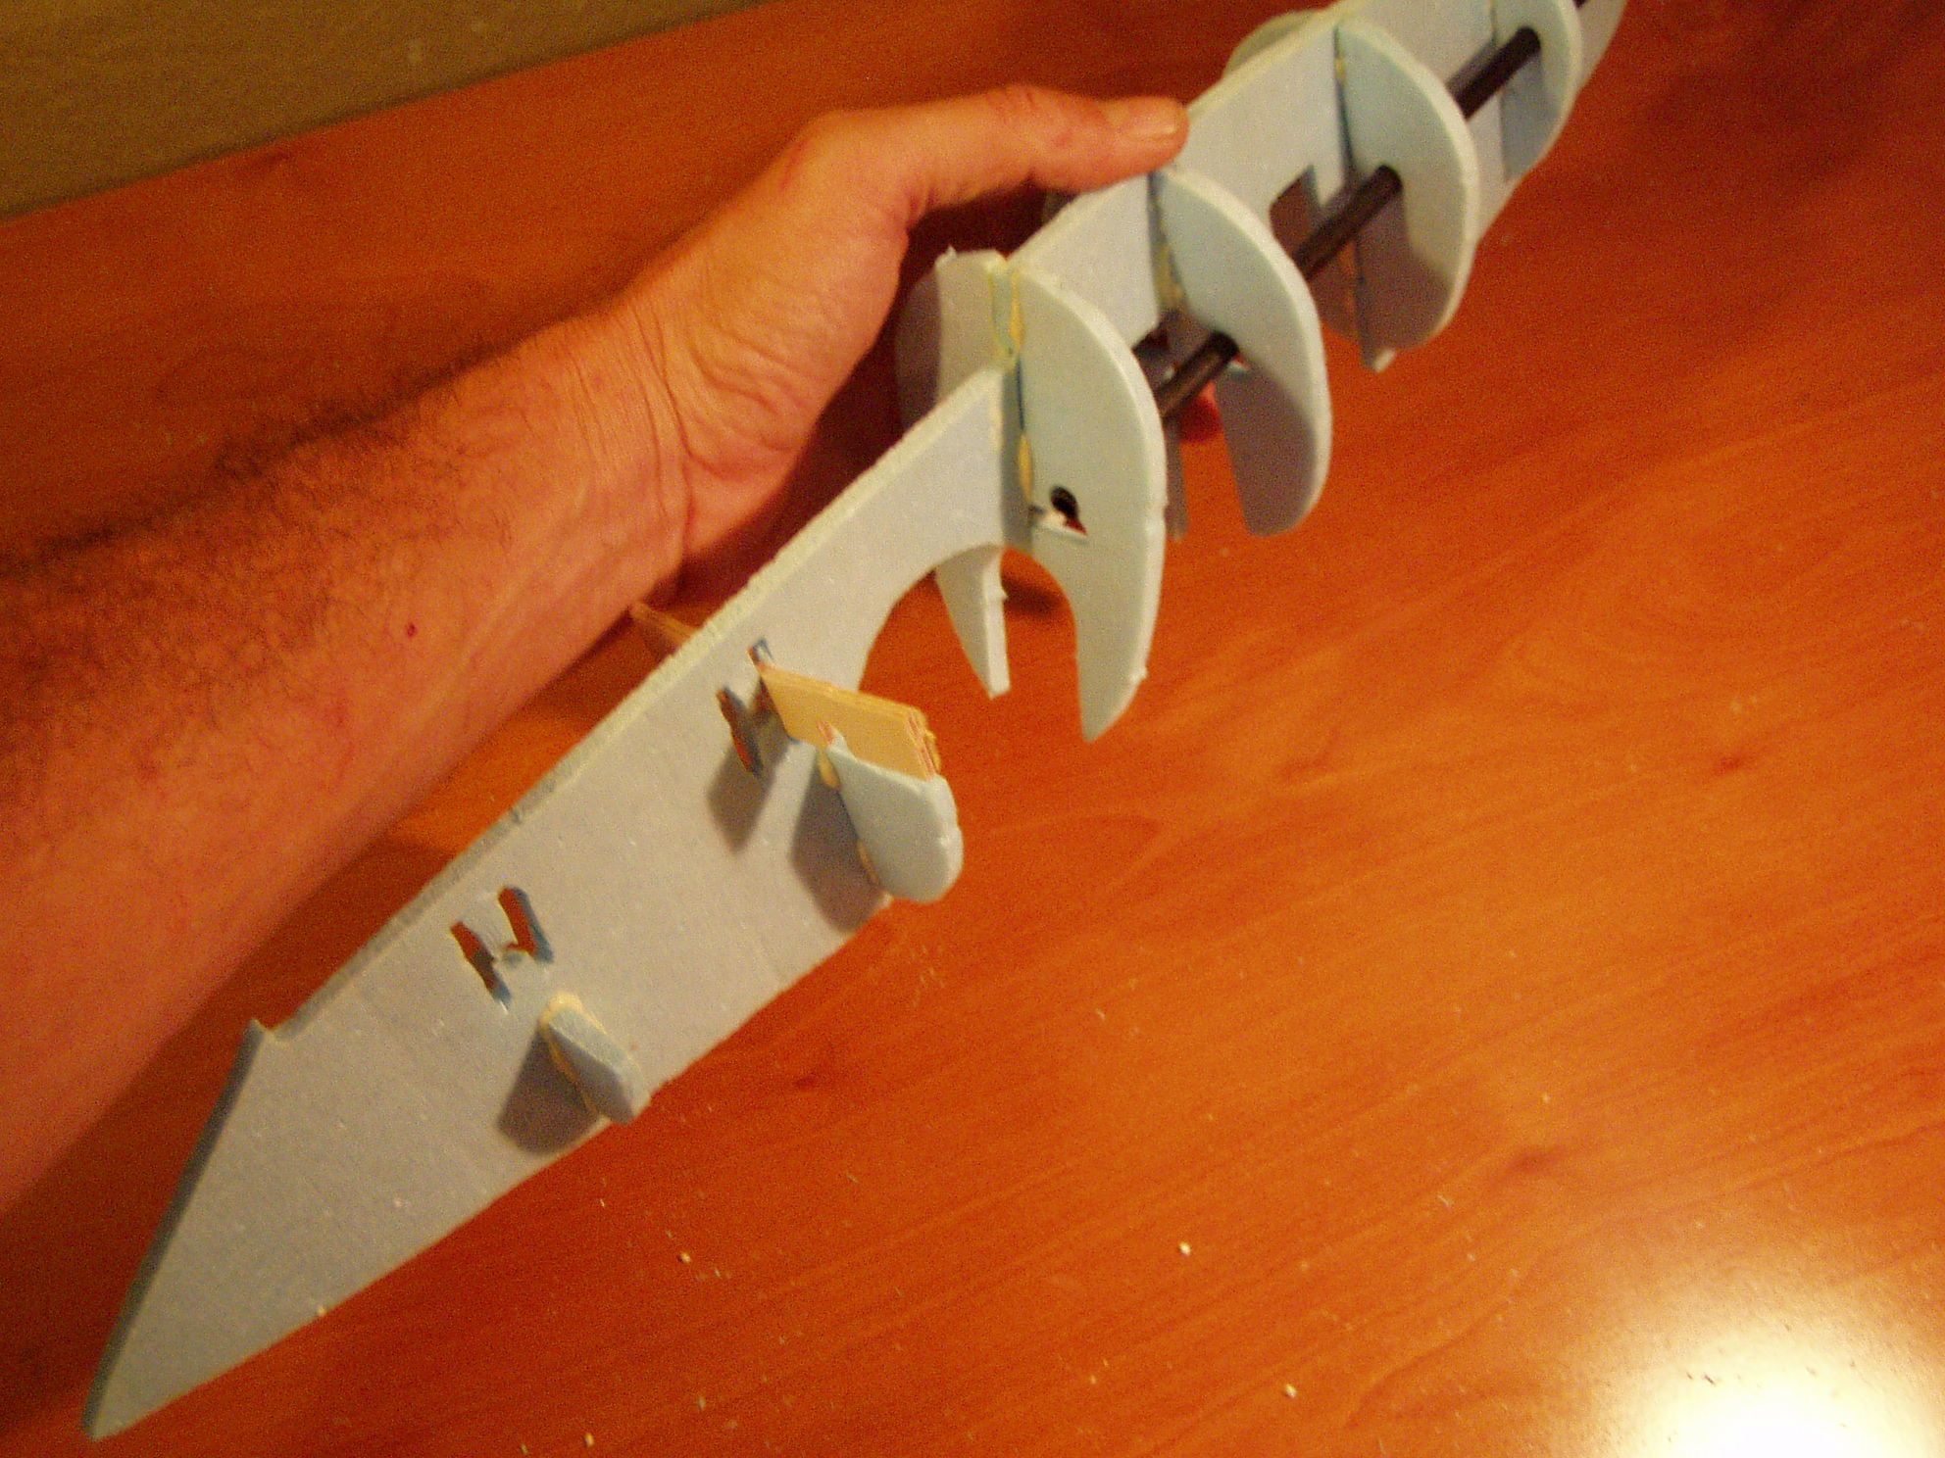
The main fuse carbon fiber shafts are slid from the front and the slots for the wing braces are shown.
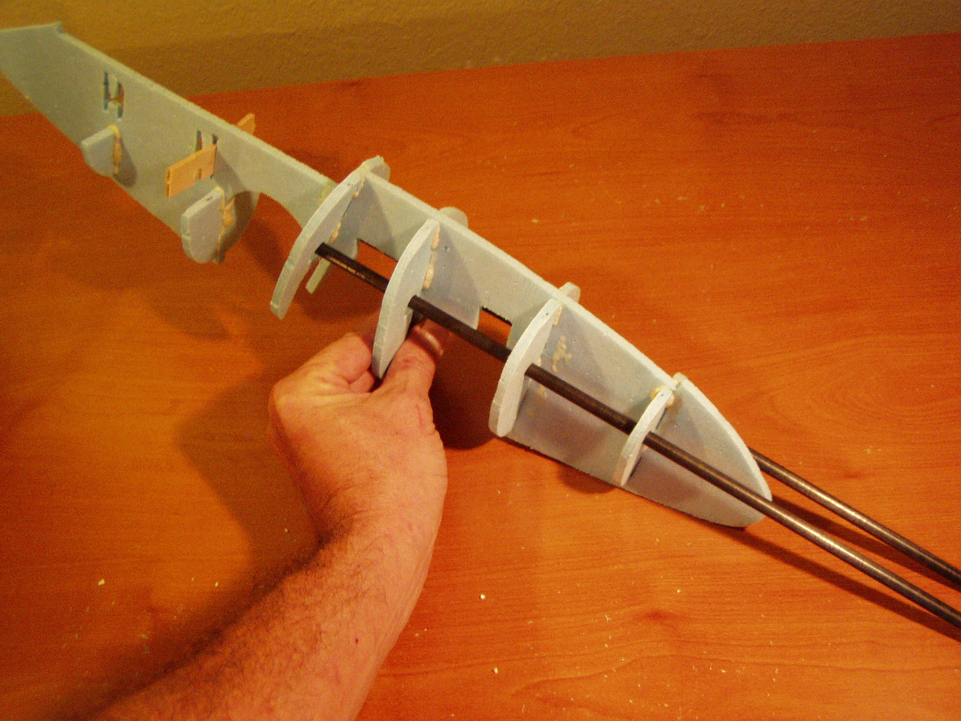
This completes the main fuselauge. We will now assemble the tail pieces.
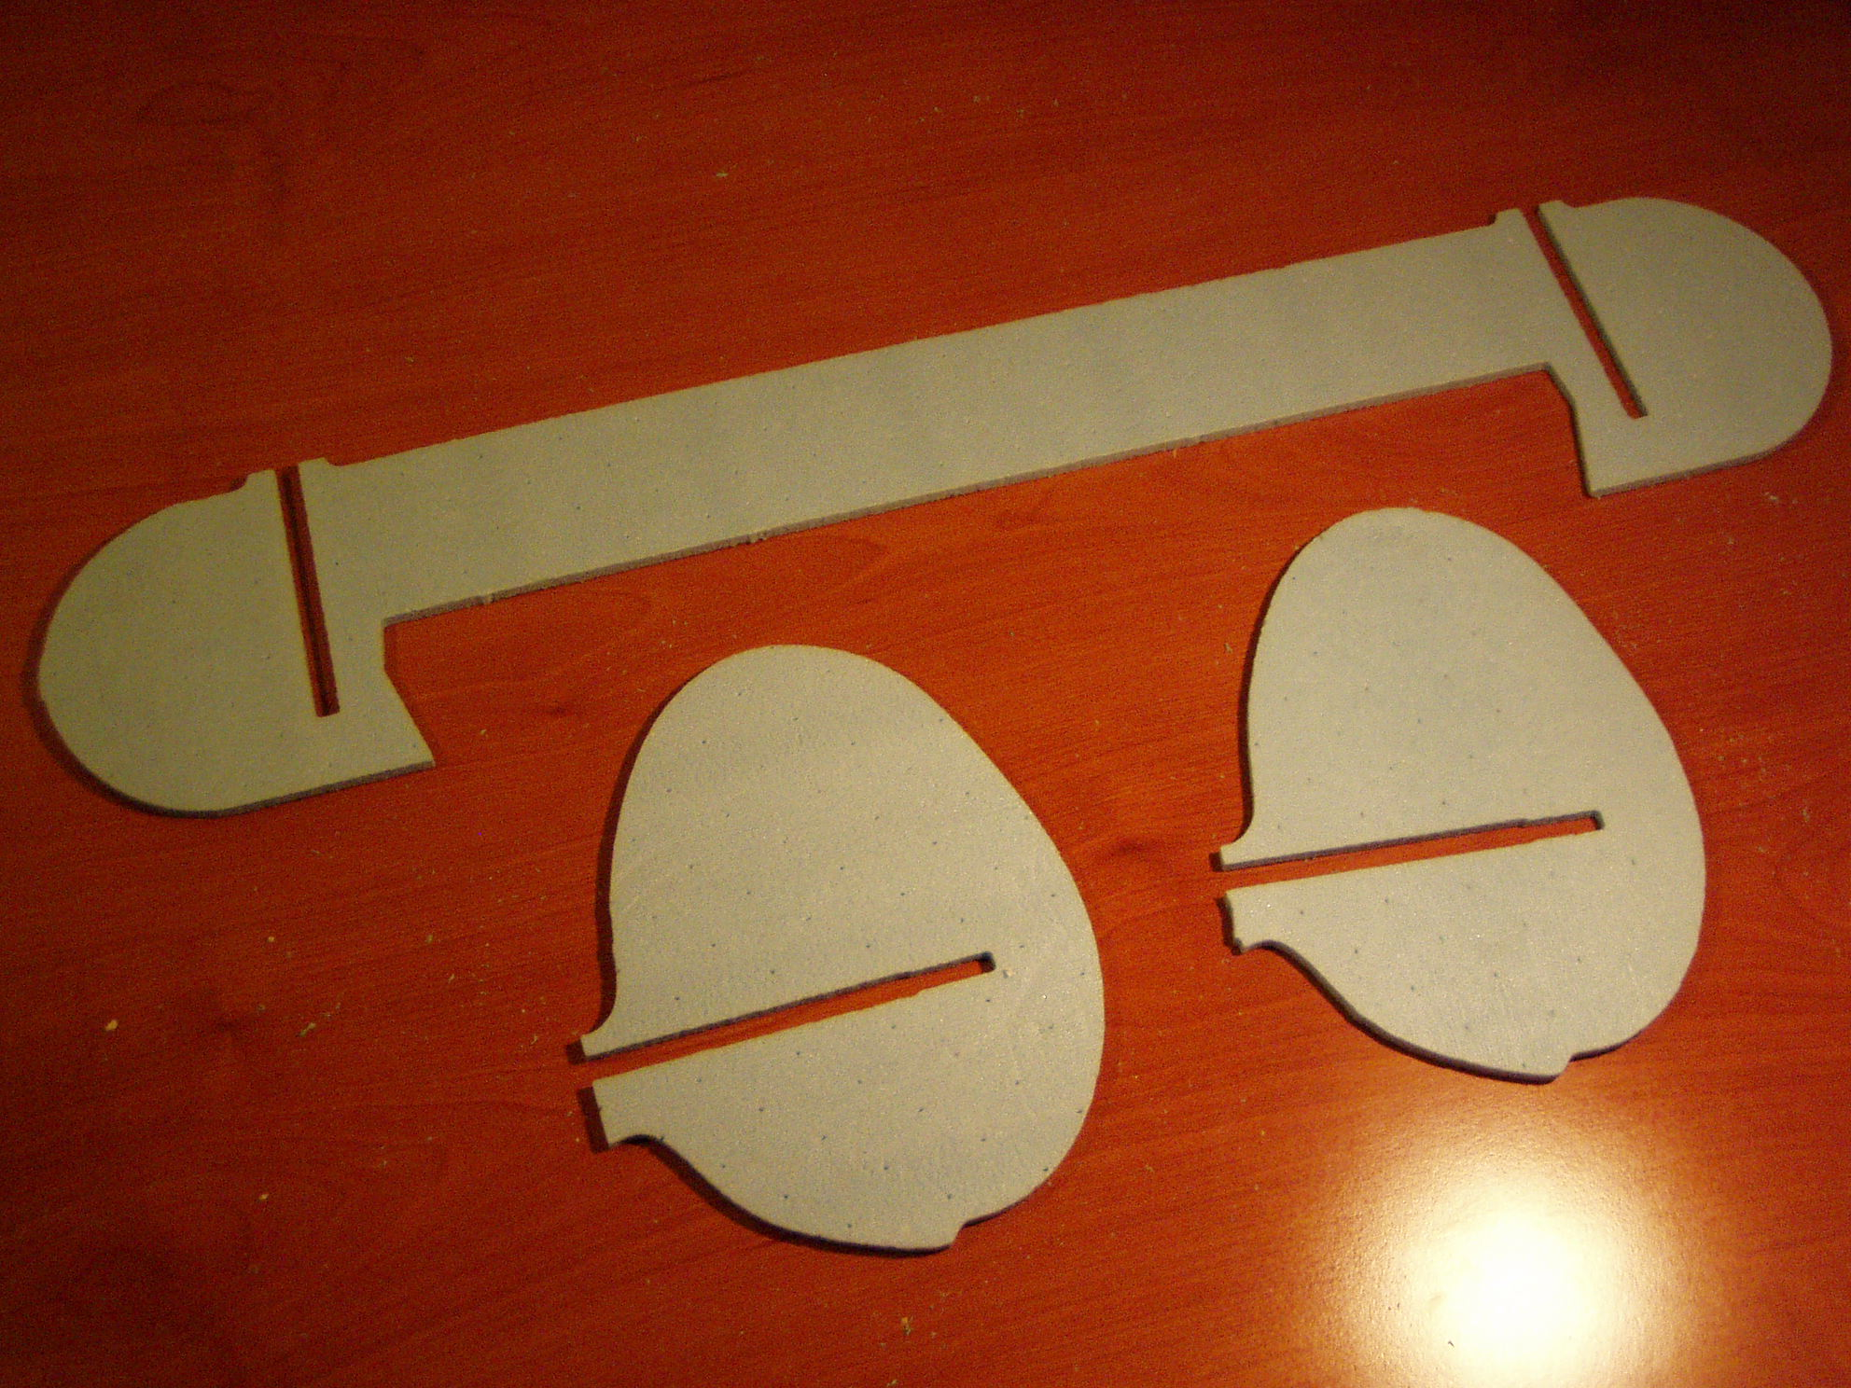
The vertical tails are self explanatory and nothing needs to be done with them unless you are interested in adding rudder control. There are three options concerning rudder: No rudder (the suggested configuration), a single rudder in the boom that does not have the elevator servo, two rudders with two servos.

The horizontal tail is reinforced with the hardwood strips. A slot is cut at approximately the half way point between the leading and trailing edge just long enough to accommodate one of the strips on each side as shown. It is easier if the cut is not all the way across.
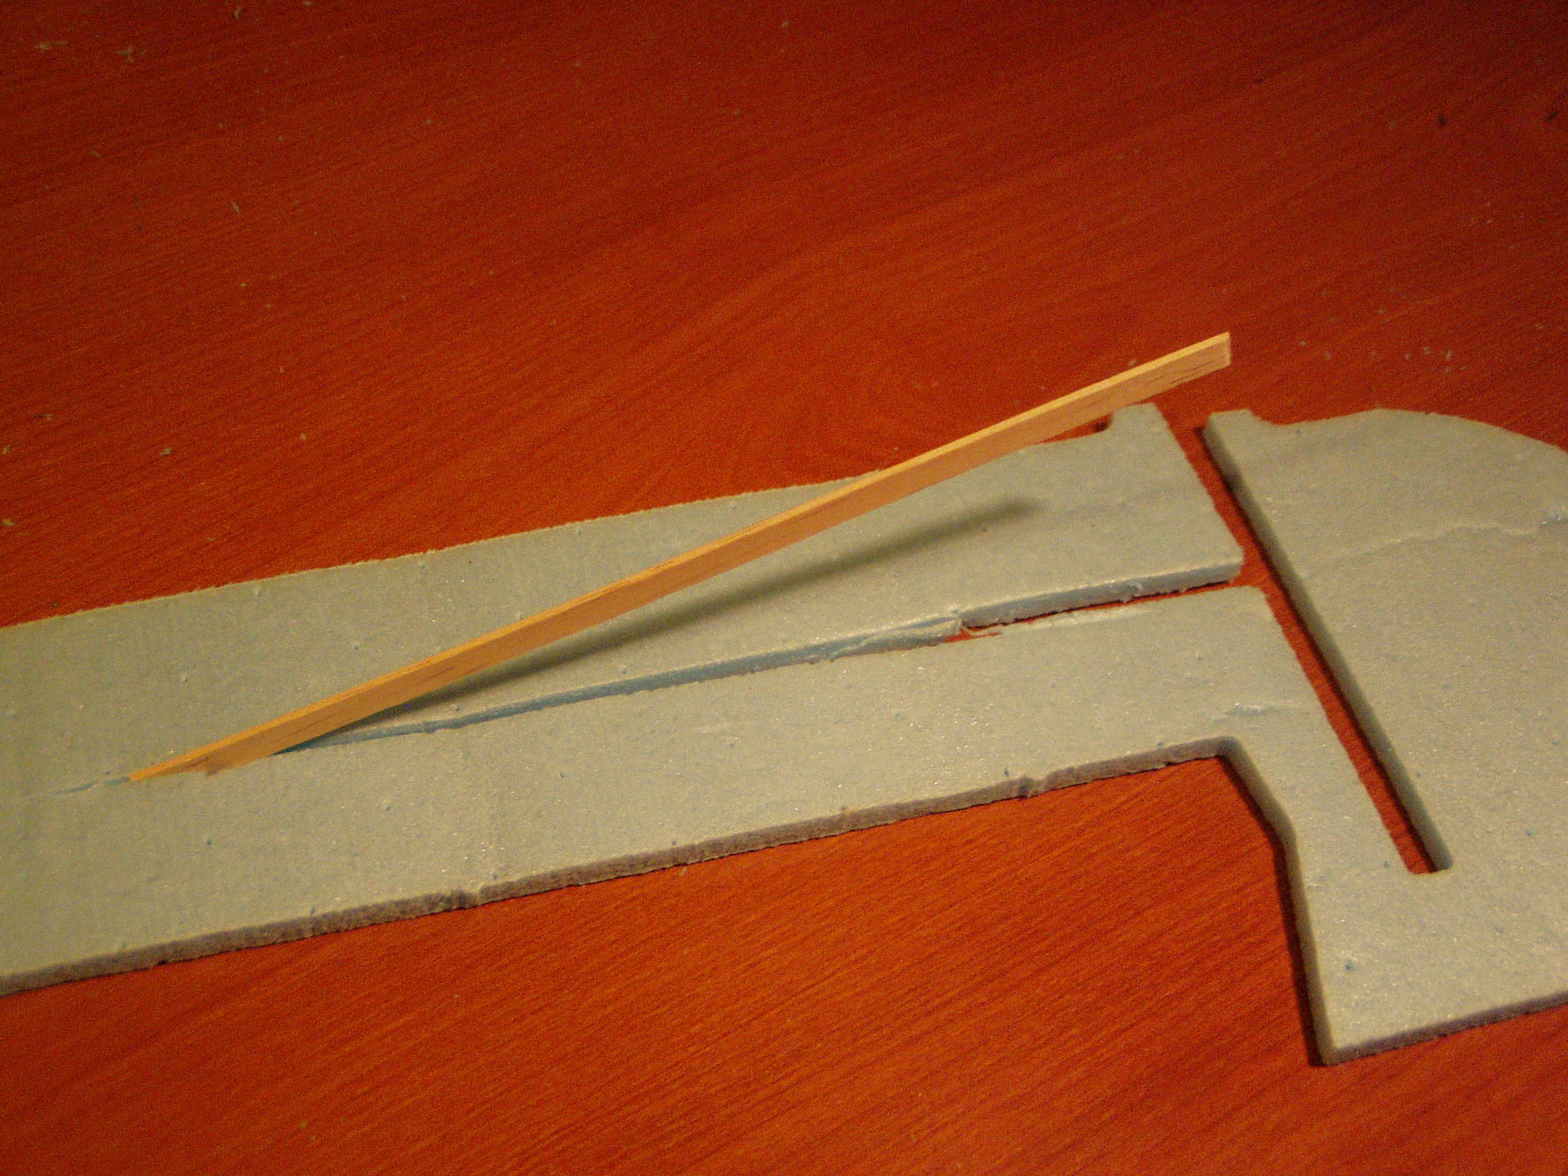
The horizontal tail is reinforced with the hardwood strips. A slot is cut at approximately the half way point between the leading and trailing edge just long enough to accommodate one of the strips on each side as shown. It is easier if the cut is not all the way across.
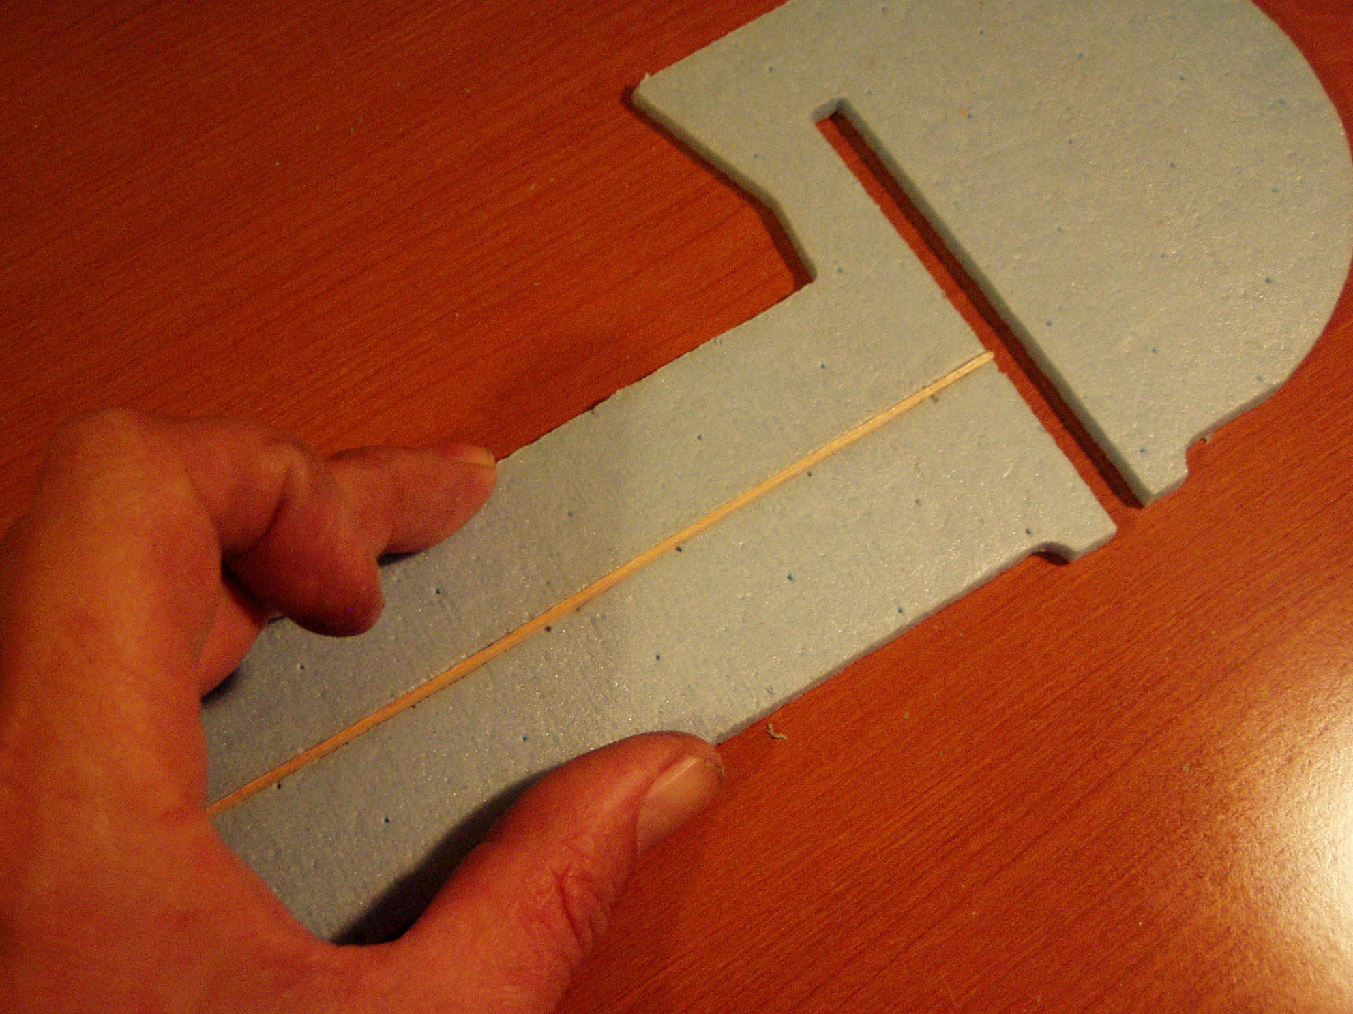
clamp the joint closed with straight pins to your cardboard work surface.
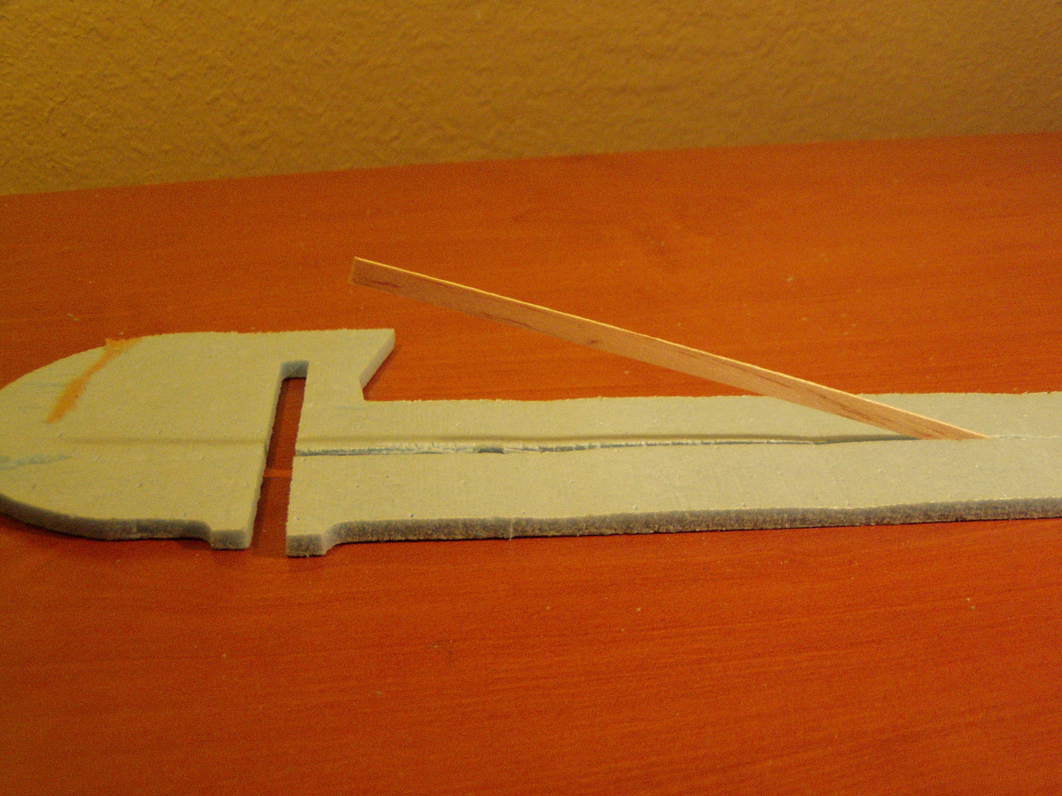
The opposite side is done in the same manner.
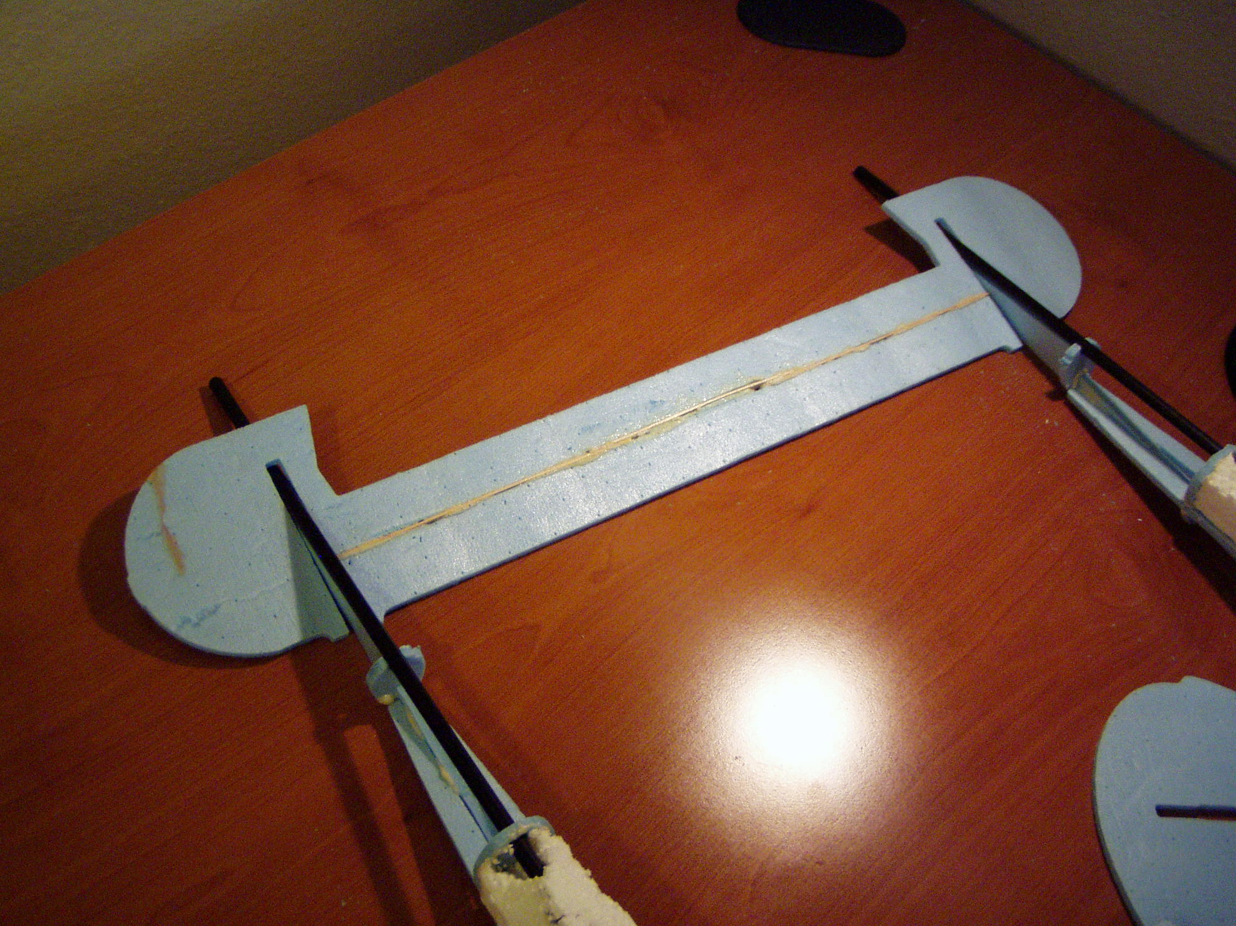
Once the glue has dried on the two outboard hardwood strips, cut the foam all the way across and place a third strip in the middle as shown in the photo. This will givethe horizontal stabilizer good rigidity.

Congratulations, all of the subassemblies are now ready to join together.

